Freshman Starter Kit

Website User Guide

http://codehers.pythonanywhere.com

Freshman Starter Kit is a website designed for Freshman in EECS. This guide will walk you through each feature that the website has with graphics. This guide is made for first-time users that either want to help freshman with reviews and posts, or want to have access to those reviews.

# Main Page

When you first enter the Website, you will encounter the main page. You can either scroll down to see all the options that we have available, or you can click on “Get Started” to be taken to those options automatically.

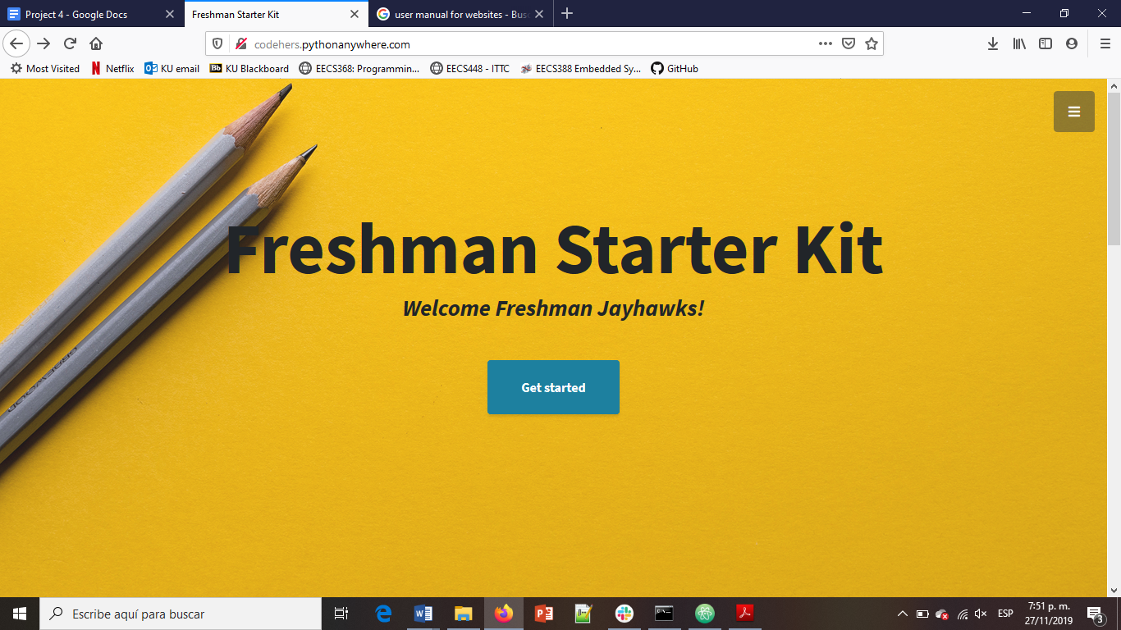

The Get Started button not only has the ability take you automatically to the options, but it also works as a timer starter/restarter. The timer that it initiates is the one you will be able to see if you go to the “Time Management” option. You can learn more about this option by reading the  **“Time Management”** subtitle.

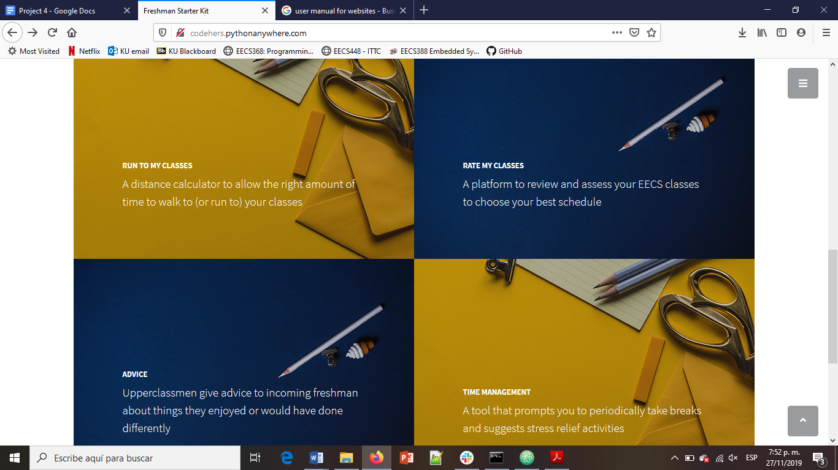

The options available are: **“Run to my classes”**, **“Rate my class”, “Advice”,** and **“Time Management”.** All of the options mentioned can be accessed through the main page or by links provided on the side menu. (read **“Side Menu”** subtitle for more information)

# Side Menu

There is a side menu available in any page. It can be accessed by clicking on the symbol with the three lines on the top right corner of each page. The contents of the Menu vary a little depending on the page you are at, but the functionality intended is the same: link you to another page directly.

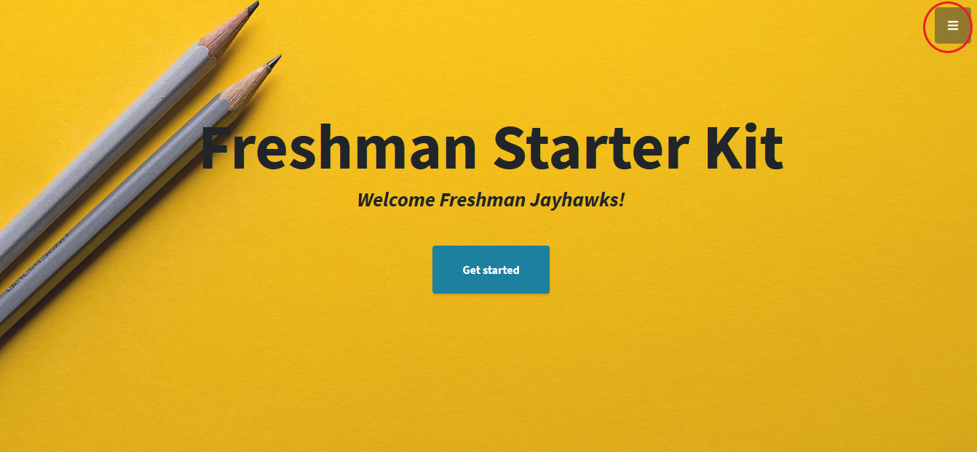

Therefore, if you wanted to, for example, go from the **“Time Management”** back to the **“Main Page”,** you could use the Side Menu to do so.

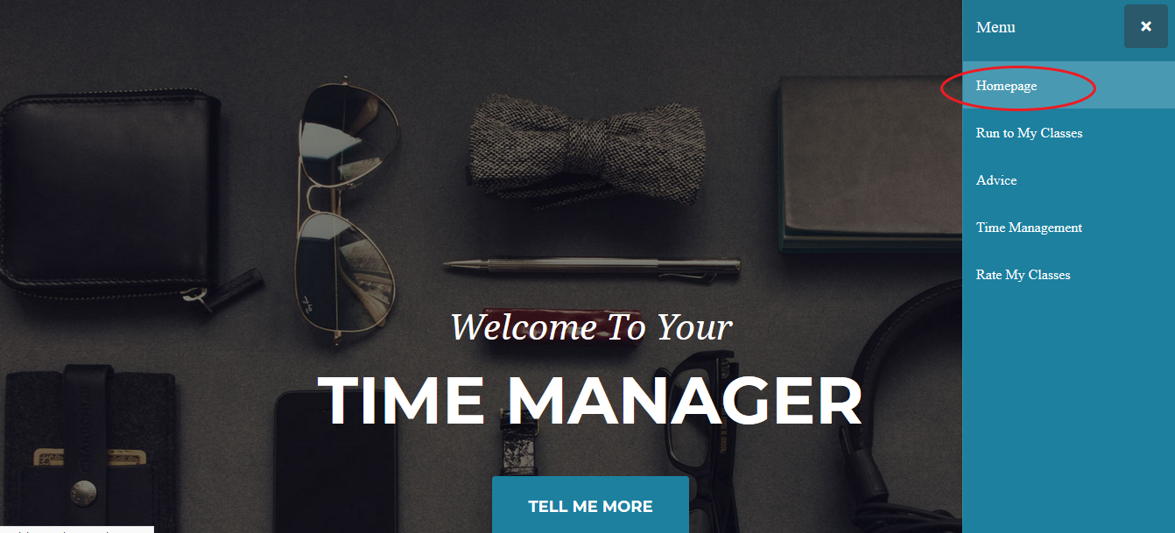

# Run to my Classes

Missing.

# Rate my Class

Once you are in the **“Rate my class”** page, you will see two options: Rate the Class or View the Ratings for a class.

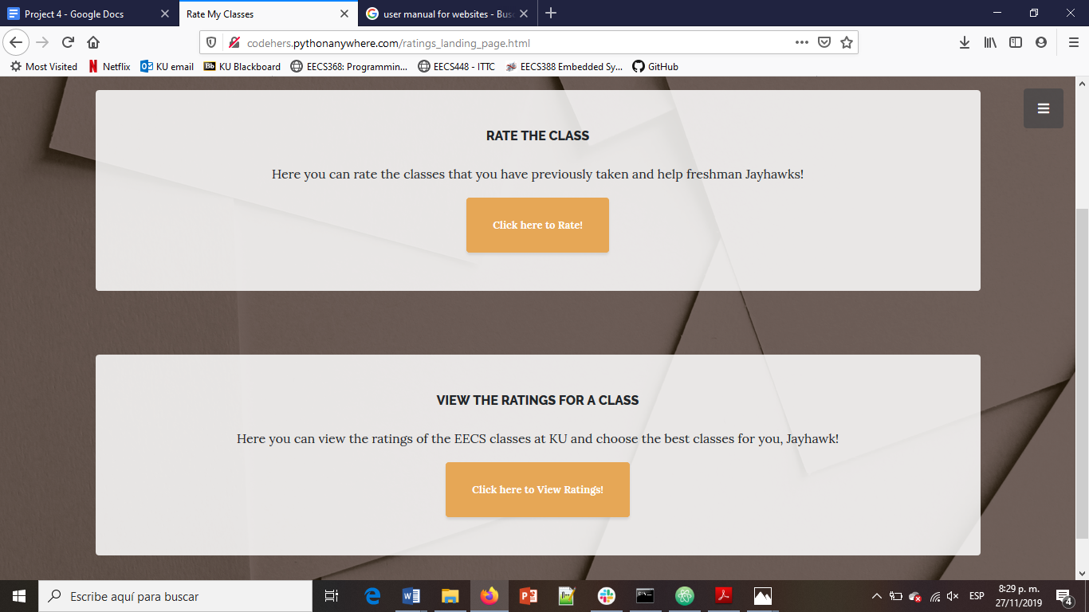

Rate the class will take you to a form that you will have to fill out if you want to leave a rating for an EECS class. Fill all of the fields to be able to submit the form. Once you are done with your rating, click on the “Rate Class” button. The page will then immediately redirect you to the “View the Ratings for a Class” page.

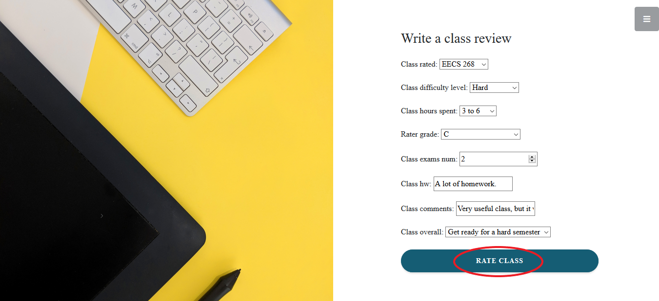

View the Ratings for a Class will take you to the place where all of the ratings are located. The ratings are organized by last-published, last-shown. If you want to filter the ratings to see only the ratings for a specific class, you can do so with the tool provided at the top of the ratings page.

1. Simply click on the small arrow pointing down to get a list of all the available classes that were rated. Select the one that you want.
2. Click on “Filter” to filter the classes that you want to see.

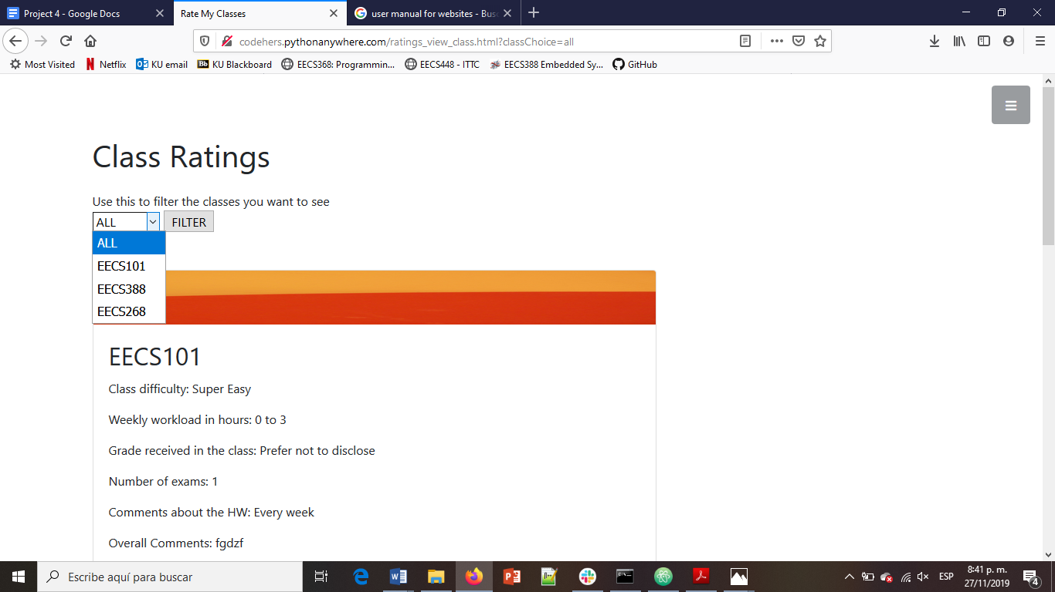

# Advice

Missing.

# Time Management

Missing.